**Dashboard Design**

|  |  |
| --- | --- |
| Date | 05 October 2025 |
| Team ID | SWUID20250215169 |
| Project Name | Global Food Production Trends and Analysis: A Comprehensive Study from 1961 to 2023 Using Power BI |
| Maximum Marks | 5 Marks |

Creating an effective dashboard involves thoughtful design to ensure that the presented information is clear, relevant, and easily understandable for the intended audience. Here are some key principles and best practices for dashboard design

**Activity 1: Interactive and visually appealing dashboards**

Creating interactive and visually appealing dashboards involves a combination of thoughtful design, effective use of visual elements, and the incorporation of interactive features. Here are some tips to help you design dashboards that are both visually appealing and engaging for users so take care of below points

* Clear and Intuitive Layout
* Use Appropriate Visualizations
* Colour and Theming
* Interactive Filters and Slicers
* Drill-Down Capabilities
* Responsive Design
* Custom Visuals and Icons
* Use of Infographics

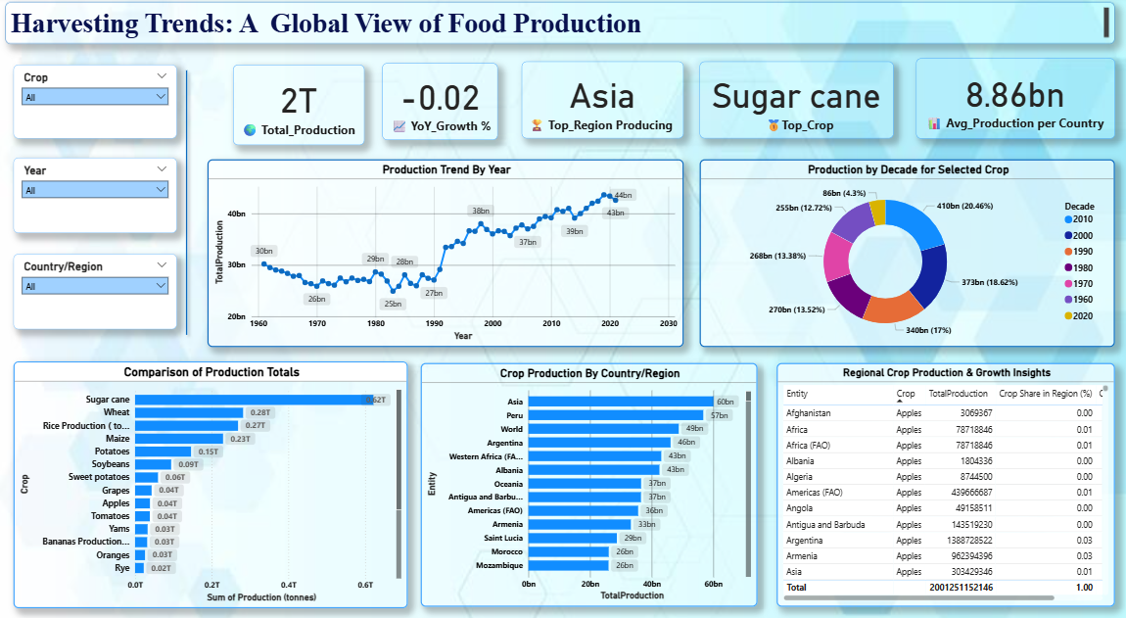

**Highlights:**

1. Total Production (2 Trillion Tonnes) — The dataset from 1961 to 2023 reveals that global agricultural production has reached nearly 2 trillion tonnes, emphasizing the massive growth in global food supply driven by technological and agronomic advancements.
2. Average Annual Production (8.86 Billion Tonnes) — Consistent annual output highlights agricultural stability despite global population growth and climate changes.
3. Top Crop: Sugar Cane — Sugar Cane dominates global production, confirming its central role in tropical agriculture and bioenergy industries.
4. YoY Growth % (-0.02) — Indicates that the rate of production increase has flattened, showing that the global food system is reaching a mature, stable phase.

Insights from Visuals:

1. Production Trend Over Time — A steady upward trend from 1961 to 2010 shows rapid agricultural expansion, while post-2010 data indicates a plateau, suggesting efficiency improvements rather than expansion.
2. Regional Comparison —
   * Asia emerges as the global production hub, driven by large-scale Rice and Sugar Cane cultivation.
   * Americas show strength in Wheat, Maize, and Coffee production.
   * Africa demonstrates growth in fruit and coffee yields, marking developing agricultural potential.
3. Crop Comparison — The top three crops — Sugar Cane, Wheat, and Rice — contribute over 70% of global food production, revealing high dependency on limited crop categories.
4. Decade-Wise Production —
   * The 2000s and 2010s decades recorded the highest outputs due to technological adoption and better irrigation.
   * Early decades (1960s–1980s) reflect gradual capacity building.
5. Coffee, Green Production by Region — Shows how Africa, Asia, and the Americas share dominant roles in coffee cultivation, highlighting export-oriented agricultural specialization.
6. Regional Crop Growth Table — Offers detailed insights by crop and region, showing Asia with consistent year-over-year gains, while smaller regions fluctuate due to climatic and economic shifts.